

**LAB-01**

**Title: Installation of Xampp and Familiarization of its different**

**component like Apache, MySQL.**

**Name: Azizul Abedin Azmi**

**ID: 2022-1-60-130**

**Section: 02**

**Course Code: CSE302**

**Course Title: (Database Systems)**

**Date: 08/07/2024**

**Course Instructor:**

**Dr. Mohammad Arifuzzaman**

**Associate Professor**

**Department of Computer Science and Engineering**

**Exercise A:**

**create table student (Stu_id int(5),Stu_name varchar(10),Stu_address varchar(10),Course_id**

**varchar(10))**

**insert into student values**

**(401,'Amir','Dhaka','CSE-103'),**

**(402,'Ana','Sylhet','CSE-302'),**

**(403,'Bobi','Rajshahi','CSE-302'),**

**(404,'Rupa','Dhaka','ICE-305'),**

**(405,'Asif','Dhaka','ICE-305'),**

**(407,'Robi','Khulna','ICE-245'),**

**(408,'Nazmul','Khulna','ETE-465'),**

**(409,'Ovi','Barisal','CSE-302')**

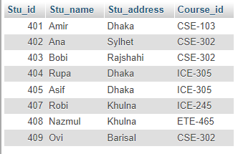

**create table course_info (Course_id varchar(10),Course_name varchar(10),semester varchar(10),year int(4))**



**insert into Course_info values ('CSE-302','Database','Fall',2016), ('ETE-465','Database','Spring',2016), ('CSE-302','Database','Spring',2015), ('ICE-245','Algorithm','fall',2015)**

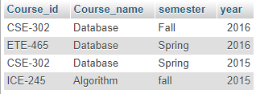

**Exercise B:**

**SELECT * FROM student WHERE stu_address ='Khulna';**

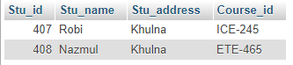

**Exercise C:**

**SELECT Stu_name,Course_ID FROM student WHERE Course_id ='CSE-302';**

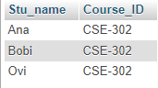

**Exercise D:**

[**SELECT**](http://localhost/phpmyadmin/url.php?url=https://dev.mysql.com/doc/refman/8.0/en/select.html)**Stu_name,Course_ID FROM student WHERE Course_id ='ICE-305';**

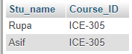

**Exercise E:**

**SELECT * FROM course_info WHERE year ='2015';**

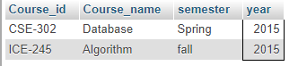

**Exercise F:**

**SELECT * FROM course_info WHERE semester ='fall';**

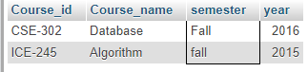

**Conclusion:**

**From today’s lab we learn what is Structured query language, MySQL and how to use it. Then we learn how to create table, insert data in table, search data from table manually With SQL command.**